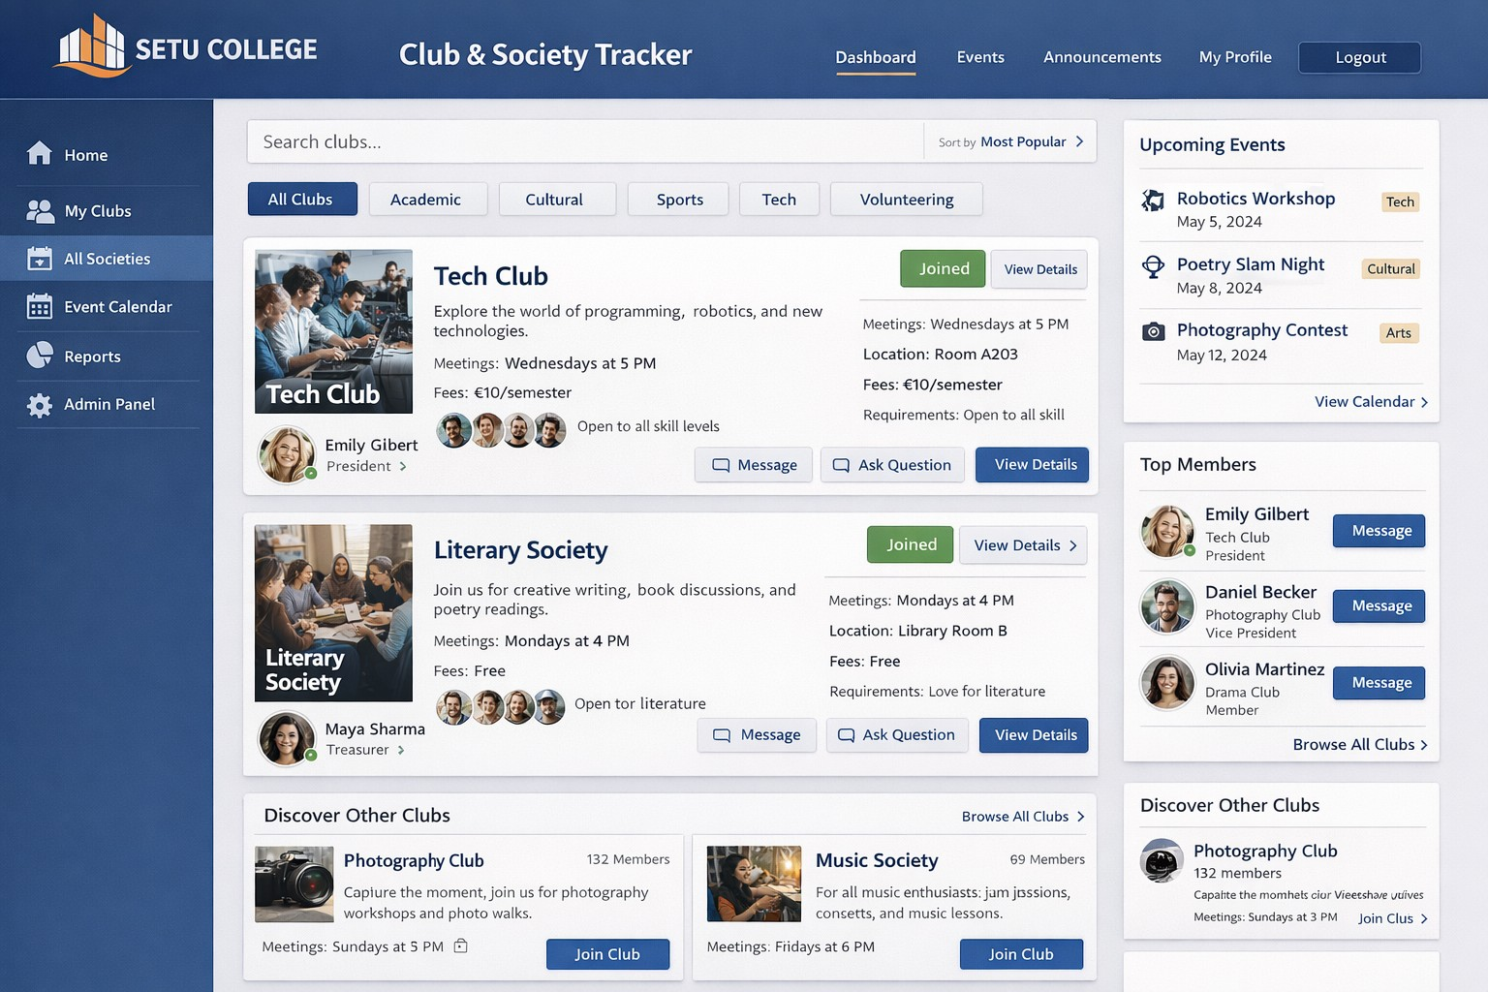

Done by:

Esme Robertson 20112370, Viktoriia Novytska 20117968, Max Burke 20114254, Seán Matthews 20111328
Software Engineering Practice
Patricia O Neill

CLUB & SOCIETIES TRACKER SETU

WEB APPLICATION

Table of Contents

Introduction 2
Product vision 2
Research of similar applications 3
Features 4
Revised Features 5
User Personas 5
Ava O’Rourke 5
Joe Joyce 6
Micheal Johnson 6
Anna Hennessy 6
User Scenarios 7
Ava O’Rourke 7
Joe Joyce 7
Micheal Johnson 8
Anna Hennessy 8
User Stories 8
Junit Testing 9
Prototype 14
References 15
Reflection 16

1

Introduction

Clubs and Societies are important part of student’s life at South East Technological University, helping students make friends, explore interests and get involved in college activities. However, finding clear and up-to-date information about these societies can often be difficult due to scatted system and limited communication.
In this project we focus on the design and planning of the Clubs & Societies Tracker application. Rather that developing a full system, the aim is to research user needs and propose key features that would improve how students discover, join and engage with societies. In our work we showing importance how more structured, user-friendly platform could enhance students experience and participation in college life.

Product vision
The aim of our project is to design and develop digital platform that improves how students access information about Clubs and Societies in SETU. Our application focuses on increasing student engagement, improving communication and ensuring that information about societies is clear, organised and regularly updated.
- Target users (FOR)
The primary users of this application are students of South East Technological University (SETU), including first-year, international, transferred and returning students who wish to become more involved in college life.
- User need (WHO)
Who need a simple, accessible and reliable way to find accurate information about Clubs and Societies, including meeting times, locations, membership details, fees and upcoming events.
- Product Description
The SETU Clubs & Societies Tracker is a mobile student services application designed specifically for the SETU community.
- Key benefits (THAT)
That brings together all club and society information into one organised and user-friendly platform, helping students stay informed, participate in college activities and manage their involvement more effectively.
- Competitive alternative (UNLIKE)
Unlike the current SETU website and similar university platforms, which can be difficult to navigate and are not always consistently updated, our solution focuses on clarity, accessibility and real-time information.
- Primary difference (OUR PRODUCT)
Our product provides real-time updates, a structured event calendar with reminders, direct messaging with committee members and secure login using SETU student accounts.

2

Research of similar applications
SETU Clubs and Societies website
The current SETU Clubs and Societies information is available through the SETU Clubs and Societies page. It allows students to view societies, apply for membership and access some event information (SETU, 2026).

Strengths
- Students can apply to join societies
- Clubs can be marked as open or closed
- Social media links are included
- Messaging functionality is available
- A news section exists for announcements

Weaknesses
- Information is sometimes outdated or incomplete
- Events are not consistently displayed
- The layout is not very user-friendly
- Some sections contain little or no useful content
- Committee member information is often missing
- The platform is difficult to find within the main SETU website

TU Dublin (TUD) Clubs and Societies Platform
The TU Dublin platform provides a more structured and visually clear system for viewing clubs and societies (TU Dublin, 2026)
Strengths
- Clean and simple layout
- Strong filtering system
- Meeting times and locations clearly displayed
- Up-to-date central event calendar
- Events categorised by type
- Contact and committee information clearly visible
Weaknesses
- Login required to apply for societies
- Unclear handling of inactive societies
- Limited explanation when clubs are closed

3

Features

The majority of the initial features were ideas that we got while looking at the similar apps for product vision. Some of them are features that the other sites had, and others are features that we felt they were missing.
There would be a list of clubs and societies. The ability to filter the list of clubs and societies would be included to help the student whittle the list down to a shorter list that better aligns with their interests. There would also be the ability to filter the list by campus, so that clubs running out of SETU Carlow don’t show up for a student that attends SETU Waterford.
The user would be able to login with their student details. When signed in the student would be able to sign up for clubs and societies and be able to pay the associated fees for signing up. News would be sent to students through their accounts email about the clubs that they had signed up for, such as special events or if a meeting was not going ahead. There would also be the ability to sign up for events that clubs or societies are putting on. This would be for events where the club / society is going on a trip or to a competition and they need to know how many people are attending.
Upon clicking on one of the clubs or societies there would be more information about the club there. Such as the President/Admin and other people that run the club. It would include a short description of the club and what they do, as well as any equipment required to participate. The user would also be able to message the president / admin of the club through the site, if they need to ask any clarifying questions.
For the calendar it would show all the meetings of the clubs and societies with filtering available. The meetings could be different colours depending either on what they are going to do in the meeting, if it’s a competition or just a meet up, or each club/society could have a dedicated colour so that they could see when each club was meeting.
There would also be a map on the site, where the user would be able to choose which of the campuses is shown. When a room is hovered over or clicked on the club or society that was meeting there would be shown, along with the name of the room and when the club/society is meeting there. If the club was clicked on, then it would take the user to the page for the club/society.
Based on our research, we identified several important features that will influence the design of our application:
- Clear and structured club pages - each society should have organised information including description, meeting times, location, fees and requirements, so students can quickly understand what the club offers.
- Filter system for clubs and events - users should be able to search and filter by category or interest to make navigation easier.
- Regularly updated event calendar - shared calendar will allow students to see all upcoming events in one place.
- Join functionality - students should be able to join or leave societies directly through the app.
- Messaging between students and committee members – direct communication will allow students to ask questions easily.
In addition to these features, we aim to improve existing platforms by including:
Real-time updates, push notifications and reminders about meetings and events, listing of committee members and contacts of head in committees, secure login using SETU student accounts.
4

Revised Features

After introducing the user personas to our assignment, we went back through our feature list to see if there are any changes or updates that could be added that help the personas we created. These could be more features or updated already existing ones:
To begin, we believed our first feature that separates the clubs by campus was a must-have as it would be important for those under the SETU name to not get mixed up between two of the same club that are on in different counties/campuses. It would also be very useful to have this “filtering” system, so that users would be able to filter down to the type of club which they have interests in.
One of the features that we decided to change from our initial list is the calendar feature which would show the dates and locations of each club or if it is on, we decided to have this calendar feature update regularly and not be static as some days the club could change room and some days it could be cancelled altogether.
A feature we decided we wanted to add to our original list was the feature for a user to create a club or society if there wasn’t one already existing in the college, this would be overseen by the college board and student union so that there wouldn’t be the creation of “joke” clubs/societies. We decided on the creation of this feature because of the new view we gained from creating our user personas. What if you go to a college but the college doesn’t have a rock music club? etc.
As per our review, the rest of our feature list successfully met the requirements of our personas that we created and we are happy to leave them as they were.

User Personas

Ava O’Rourke

Ava, a student wanting to make a society Ava, age 21, went to Newbridge College, a private secondary school. She Passed her leaving certificate and get into the biosciences course in SETU but decided to defer for the year. She travelled for the majority of that time. During her time away she spent a lot of time near oceans and realised she was really interested in the animals in the ocean. Ava is not particularly gifted with technology but she has a basic understanding of how the basic things work. Ava looked for a society that might have to do with marine animals or just animals in general but she couldn't find one that would match her schedule. Coming into her second year Ava has decided that she would like to set up her own society to do with marine animals, and is looking into how to do that. She knows that creating the society has to be done through the university but is looking to put it on the clubs and societies app to help let people know that it will soon be available to join.
5

Joe Joyce

Joe Joyce, aged 17, is a PLC Student in SETU Waterford. He was born in Tallaght, grew up in Finglas, his father works abroad and his mother works as a physician, he dropped out of the DEIS school in Tallaght, and decided he wanted to pursue music, as it was his favourite subject in school.
After searching through different courses, he came upon a course in SETU. After living with his family all his life, he decided he wanted to try being independent for once. He got accommodation near the college and moved down the end of Summer. After joining the college, he didn’t really know anybody or if anybody had the same interests as him, so he decided to see if there were any musical clubs going for music enthusiasts.

He had particular interest in using GangStalkers to see if there was any music creation club, production clubs or just general interest in a specific artist or genre of music in a society. With the use of an application such as this he would be able to locate friends of similar interests or goals and go to different events to do with these interests.

Micheal Johnson
Micheal Johnson, age 22, college student at SETU Waterford studying Arts and Crafts. Micheal comes from rural Mayo. He attended VALLEY N S. in Mayo West for primary school and St. Muredach’s College for secondary school. He is currently staying in student accommodation on campus and has much free time after classes every day.

He travels home every 3rd weekend to see his family at home in Mayo. Micheal is eager to engage in college life and to explore Waterford city. Micheal was a member of his local GAA club growing up and wants to continue playing hurling and Gaelic football. Michael may use the app to find out if there are any clubs withing SETU Waterford that engage with his sporting hobbies and/or social life in Waterford city. Micheal may also message some of the chairpersons of clubs he is interested in if he has additional questions that are not answered in the club description.

Anna Hennessy
Anna is 25, she is a final-year Event Management(year 4) student from Dublin at South East Technological University (SETU), Waterford campus. She is the Chairperson of the Business & Entrepreneurship Society and is responsible for uploading and managing all society information, including meeting time, events, membership fees and committee details also any updates. Sarah is confident using digital technology such as mobile apps, email and social media, but she is not a programmer. She prefers simple, clear systems that allow her to update information quickly.
Why Anna would use the application:
6
- she can upload and update meeting times, events, membership fees and committee info quickly and easily;
- send announcements and reminders to members instantly;

- keep members informed and engaged without repeating same messages individually;
- track student participation and events attendance;
- manage event schedules and room bookings efficiently;
- share tasks and updates with committee members;
- ensure society information is accurate, professional and easy to access;
- receive real-time feedback from members through the platform;
- keep a clear record of past events, meetings and announcements for future planning;
- save time and reduce administrative workload

User Scenarios

Ava O’Rourke
Ava is a second year student in South East Technological University. She has decided to set up a society revolving around marine wildlife. She would like to put the society up somewhere so that other students can learn about the society. She also wants people to be able to join the society and is unsure about how to facilitate the fees. Ava has asked others who have set up societies about how they went bout getting the word out to others that there was a new society. They suggested putting posters around the campus and putting it up on the clubs and societies website. Ava looks into the site and learns that the site will deal with the joining fees internally so that she doesn't have to deal with them herself.
Ava logged into the site with her student email and started setting up a society listing on the site. She put in the details of when and where the meetings would take place. She also added her details as the president of the society ; so that other students could contact her with questions about the society.

Joe Joyce
Joe Joyce is a PLC student in SETU, he is studying music on the College Street campus. He decided that he wanted to join the college’s board game club to see if he could meet people with the same interest in MTG as him. He overheard a few people talking about GangStalkers, so he decided to download the app and see if there were any clubs that had to do with Magic The Gathering. He utilised the apps filtering feature to search for clubs on his own campus as he knew that there was probably another club of the same type on the other campus, he was able to find another board game club that fit the description and was also on his campus.
After joining the club on his campus, Joe enjoyed going to the club every week to play MTG with his new friends. The club had to be cancelled one week due to an awards night hosted on the same day as the club , luckily the app has a feature that alerts the club members of any club when there is a change in date or a cancellation of the club for whatever reason.
7

Micheal Johnson
Micheal has just finished his first week of college and wants to join a new club with his new friend that he has made. They both share interests in GAA sports and would like to see who the better player is. Micheal decides to use the new SETU clubs and Societies app to find a suitable GAA Club or Society that would allow the two friends to play against each other. Micheal uses the search feature in the app to narrow down his options and finds two clubs which fit his needs. One of the clubs is a
Hurling only club which runs between 4 and 6 o’clock on Monday and Wednesday. The other covers handball and rugby and runs between 5 and 8 on Monday and Tuesday. Micheal decides to message the presidents of both clubs asking if it is ok if he attends just one day a week from each club, preferably the Tuesday and Wednesday. Both presidents return his message confirming that there is no issue with him attending one day from each and that the clubs occasionally do a crossover day on Saturdays, details of which is posted on the events page of the app roughly 2 weeks in advance. Micheal tells his friend about his findings, and they agree to attend the Tuesday and Wednesday hours. They also agree to attend the Saturday crossover if they are not busy with college work.

Anna Hennessy
At the start of a new semester, Anna logs into the SETU Clubs & Societies Tracker application using her SETU student account. From the society management page, she updates the weekly meeting time, adds the current committee members and posts details about an upcoming networking event for students interested in business and entrepreneurship. Once the event is posted, it automatically appears in the shared events calendar within the application. Members of society receive a notification on their phones reminding them about the event. Students who are interested in joining the society can sign up directly through the app and they can also send questions to Anna using the built-in messaging feature.
Previously, Anna had to share society information through multiple channels such as social media posts, emails, group chats. This often-caused confusions between information lot and misunderstanding. By using that web-app tracker, all societies’ information, announcements and events are available in one organised platform, making it easier for Anna to manage the society and for students to stay informed and engaged.

User Stories
Ava O’Rourke || As a club creator, I want to let other students know about my club so that they can join easily.
Joe Joyce || As a club member, I want to know when my club gets cancelled or changes room.
Micheal Johnson || As a student, I want to be able to find clubs which allow me to engage with my interests in sporting.
Anna Hennessy || As an event manager, I need a way to plan, organise and manage events efficiently, including scheduling, communication and tracking attendance.
Joe Bloggs || As a club chair, I need a way to communicate with potential new members and organise their memberships.
David Keegan || As a leaving cert student I want to see what the college has to offer me for activities to do after hours.
8

JUnit Testing
To support our project, we created a simple testing in InteliJ IDEA (Java). We created a few basic classes such as Club, Student, Event and Payment. These were used to represent the main parts of the system. For example, we tested how a student can join a club, register for an event or make a payment.
To check that everything works correctly, we used JUnit. It was easy to use and helped us test different situations. We wrote tests for things like:
- adding and removing members,
- making sure a student can’t join the same club twice,
- checking limits (like max members in a club),
- joining events,
- validating payments.
These tests helped us make sure the system behaves correctly and handles errors properly.

ClubTest:
package setu.clubs;
import org.junit.jupiter.api.Test;
import static org.junit.jupiter.api.Assertions.*;
public class ClubTest {
@Test
public void testAddMemberToClubSuccessfully() {
Club club = new Club("Hiking Club", 25.0);
boolean result = club.addMember("AB123456");
assertTrue(result, "Should add member to club");
assertEquals(1, club.getMembers().size());
assertEquals("AB123456", club.getMembers().get(0));
}
@Test
public void testCannotAddSameMemberTwice() {
Club club = new Club("Drama Society", 30.0);
club.addMember("CD789012");
boolean result = club.addMember("CD789012");
assertFalse(result, "Shouldn't add same member twice");
}
@Test
public void testCannotAddMemberWithNullId() {
Club club = new Club("Music Club", 20.0);
boolean result = club.addMember(null);
assertFalse(result, "Cannot add member with null ID");
}
@Test
public void testRemoveMemberFromClub() {
Club club = new Club("Art Club", 15.0);
club.addMember("EF345678");
boolean result = club.removeMember("EF345678");
assertTrue(result, "Should remove member from club");
assertEquals(0, club.getMembers().size());
}
@Test
public void testClubHasMaximumFiftyMembers() {
Club club = new Club("Popular Club", 10.0);
// 50 members
for (int i = 0; i < 50; i++) {
club.addMember("ID" + String.format("%06d", i));
}
// trying to add 51
boolean result = club.addMember("OVERFLOW");
assertFalse(result, "Club shouldn't exceed 50 members");
}
}
9

EventTest:
package setu.clubs;
import org.junit.jupiter.api.Test;
import static org.junit.jupiter.api.Assertions.*;
public class EventTest {
@Test
public void testEventHasCorrectLocationAndTime() {
Event event = new Event("Sports Hall", "6:00 PM", 20);
assertEquals("Sports Hall", event.getLocation());
assertEquals("6:00 PM", event.getTime());
}
@Test
public void testAddStudentToEventWhenSpaceAvailable() {
Event event = new Event("Meeting Room", "2:00 PM", 5);
Student student = new Student("John", "AB123456");
boolean result = event.addStudent(student);
assertTrue(result, "Should add student to event");
assertEquals(1, event.getCurrentStudents());
}
@Test
public void testCannotAddStudentToFullEvent() {
Event event = new Event("Small Room", "1:00 PM", 1);
Student student1 = new Student("Student1", "AB111111");
Student student2 = new Student("Student2", "AB222222");
event.addStudent(student1);
boolean result = event.addStudent(student2);
assertFalse(result, "Cannot add student to full event");
assertEquals(1, event.getCurrentStudents());
}
@Test
public void testCannotAddNullStudentToEvent() {
Event event = new Event("Theatre", "7:00 PM", 10);
boolean result = event.addStudent(null);
assertFalse(result, "Cannot add null student to event");
}
}

PaymentTest:
package setu.clubs;
import org.junit.jupiter.api.Test;
import static org.junit.jupiter.api.Assertions.*;
public class PaymentTest {
@Test
public void testValidPaymentShouldBeSuccessful() {
Payment payment = new Payment(50.0, "AB123456");
boolean result = payment.processPayment();
assertTrue(result, "Valid payment should be successful");
assertTrue(payment.isSuccessful());
}
@Test
public void testPaymentWithZeroAmountShouldFail() {
Payment payment = new Payment(0, "AB123456");
boolean result = payment.processPayment();
assertFalse(result, "Payment with zero amount should fail");
assertFalse(payment.isSuccessful());
}
@Test
public void testPaymentWithInvalidStudentIdShouldFail() {
Payment payment = new Payment(50.0, "invalid");
boolean result = payment.processPayment();
assertFalse(result, "Payment with invalid student ID should fail");
}
@Test
public void testPaymentWithNullStudentIdShouldFail() {
Payment payment = new Payment(50.0, null);
boolean result = payment.processPayment();
assertFalse(result, "Payment with null student ID should fail");
}
@Test
public void testPaymentHasDate() {
Payment payment = new Payment(25.0, "CD789012");
assertNotNull(payment.getDate(), "Payment should have a date");
}
}
10

SearchMessage:
package setu.clubs;
import org.junit.jupiter.api.Test;
import static org.junit.jupiter.api.Assertions.*;
public class SearchMessage {
// find club
@Test
public void testFindClubByName() {
Club football = new Club("Football Club", 50.0);
Club chess = new Club("Chess Club", 20.0);
Club hiking = new Club("Hiking Club", 15.0);
Club[] clubs = {football, chess, hiking};
Club found = null;
for (Club club : clubs) {
if (club.getName().equals("Chess Club")) {
found = club;
break;
}
}
assertNotNull(found, "Should find Chess Club");
assertEquals("Chess Club", found.getName());
}
@Test
public void testFindClubThatDoesNotExist() {
Club football = new Club("Football Club", 50.0);
Club[] clubs = {football};
Club found = null;
for (Club club : clubs) {
if (club.getName().equals("Rugby Club")) {
found = club;
break;
}
}
assertNull(found, "Shouldn't find non-existent club");
}
// message club
@Test
public void testSendMessageToClub() {
Club club = new Club("Debate Club", 10.0);
String message = "When is the next meeting?";
// simulation of sending message
boolean messageSent = (message != null && !message.isEmpty() && club != null);
assertTrue(messageSent, "Should be able to send message to club");
}
@Test
public void testCannotSendEmptyMessageToClub() {
Club club = new Club("Book Club", 5.0);
String message = "";
boolean messageSent = (message != null && !message.isEmpty() && club != null);
assertFalse(messageSent, "Cannot send empty message");
}
@Test
public void testCannotSendMessageToNullClub() {
Club club = null;
String message = "Hello!";
boolean messageSent = (message != null && !message.isEmpty() && club != null);
assertFalse(messageSent, "Cannot send message to null club");
}
}
11

StudentTest:
package setu.clubs;
import org.junit.jupiter.api.Test;
import static org.junit.jupiter.api.Assertions.*;
public class StudentTest {
@Test
public void testStudentCanJoinClubSuccessfully() {
Student student = new Student("Anna Murphy", "AB123456");
boolean result = student.joinClub("Football Club");
assertTrue(result, "Student should be able to join a club");
assertEquals(1, student.getClubs().size());
assertEquals("Football Club", student.getClubs().get(0));
}
@Test
public void testStudentCannotJoinSameClubTwice() {
Student student = new Student("John Doe", "CD789012");
student.joinClub("Chess Club");
boolean result = student.joinClub("Chess Club");
assertFalse(result, "Student shouldn't join same club twice");
}
@Test
public void testStudentCannotJoinClubWithNullName() {
Student student = new Student("Mary Smith", "EF345678");
boolean result = student.joinClub(null);
assertFalse(result, "Cannot join club with null name");
}
@Test
public void testStudentJoinEventWhenSpaceAvailable() {
Student student = new Student("Peter Jones", "GH901234");
Event event = new Event("Main Hall", "3:00 PM", 10);
boolean result = student.joinEvent(event);
assertTrue(result, "Student should join event with space");
}
@Test
public void testStudentCannotJoinFullEvent() {
Student student1 = new Student("Student1", "AB111111");
Student student2 = new Student("Student2", "AB222222");
Event event = new Event("Small Room", "2:00 PM", 1);
student1.joinEvent(event);
boolean result = student2.joinEvent(event);
assertFalse(result, "Student cannot join full event");
}
@Test
public void testStudentCannotJoinNullEvent() {
Student student = new Student("Test User", "XX999999");
boolean result = student.joinEvent(null);
assertFalse(result, "Cannot join null event");
}
}
12

13
Prototype
We also created a simple prototype, which shows how the main features of the system could work in practice. The prototype helped us understand how the system would work, even though we did not build a full app or user interface.

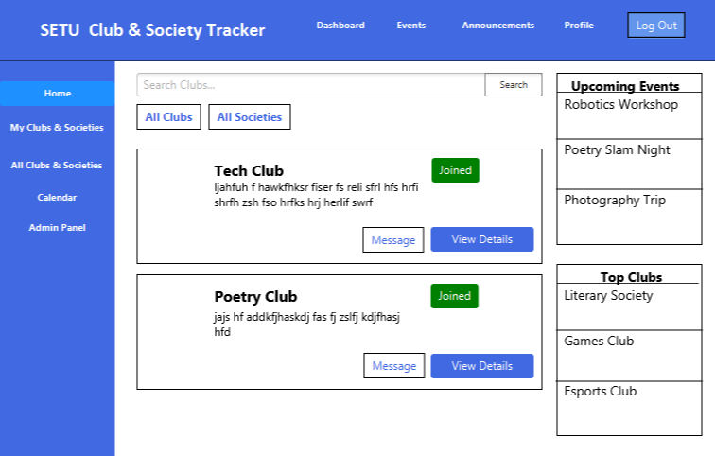

14

References

Trello link: https://trello.com/b/lwvidysT/software-engineering-assignment
GitHub link: https://github.com/EyasRobertson/SoftwareEngineeringAssignment

TU Dublin, 2026. MyStudentLife Portal. Available at: https://mystudentlife.tudublin.ie/ [Accessed 10 February 2026].
South East Technological University (SETU), 2026. Sports Clubs & Societies – Waterford. Available at: https://waterford.sportsclubsandsocieties.setu.ie/ [Accessed 10 February 2026]

15

Reflection
16

